Using Microscopes
- Label the parts of the microscope below.
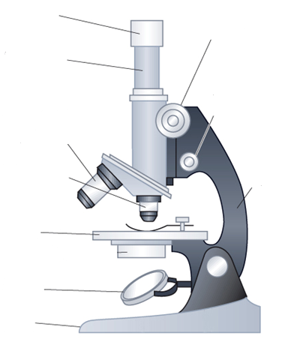
Arm
Base
Revolving Nosepiece
Stage
Microscope Tube
Objective Lens
Coarse Focus Knob
Stage Clips
Mirror
Fine Focus Knob
Eyepiece Lens

- List three rules for using a microscope.
  - _____________________________________________________________ _____________________________________________________________
  - _____________________________________________________________ _____________________________________________________________
  - _____________________________________________________________ _____________________________________________________________

- Complete the sentences below:
  - When first examining a slide use the ______ power lens.
  - When focussing, only move the objective lenses ________ from the stage.
  - When changing to high power, always look from the _______ to make sure the ______________ _______ doesn’t touch the slide.
  - When on high power, only use the ________ focus knob.

- Number the following in the correct order.
__ Place the slide on the stage.
__ Raise the microscope tube so the objective lenses are away from the stage.
__ Make sure the lowest power objective lens is in place.
__ Looking from the side, lower the microscope tube until the objective lens is close to the slide.
__ Look through the eyepiece lens and slowly raise the microscope tube until you can see your specimen.

Total Magnification = Eyepiece Magnification X Objective Magnification

- The table below indicates the possible combinations of eyepiece and objective lenses.
 |  | Objective Lens
 |  | x10 | x40 | x100
Eyepiece Lens | x5 | x50
Eyepiece Lens | x10

- Complete the table by working out the total magnification for each combination of lenses. The first one has been completed for you.

- From your table above, what is the lowest possible total magnification?

- What is the highest possible magnification?

- Explain the difference between high power and low power. _________________________ ___________________________________________________________________________________________________________________________________________________________________________________________________________________________

- The field of view is the area seen under the microscope. Does low power or high power have the larger field of view? ________________

- You often have to draw what you have seen down a microscope. What rules should you follow when drawing your diagrams?

  - ______________________________________________________________________________________________________________________________________
  - ______________________________________________________________________________________________________________________________________
  - ______________________________________________________________________________________________________________________________________

- Cut out a letter ‘e’ from the sheet. Prepare a dry mount slide by sticking the letter on the slide with sticky tape.

Set up your microscope and place the slide of the letter ‘e’ on the stage so that it is the right way up when you look at it. Look at the letter ‘e’ on low power.

- Write the letter ‘e’ as it is normally seen: _________
Now draw the letter ‘e’ as seen down the microscope: _________
What has the microscope done to the orientation letter? __________________ ________________________________________________________________

- Whilst looking down the microscope, carefully and slowly move the slide in the following directions and comment on the way the image in the microscope moves:
    - Towards you __________________________
    - Away from you __________________________
    - To your left __________________________

- Using an arrow, predict the way the image would move if you moved the slide in the direction indicated:

- ii. iii.

- Prepare a mini-grid slide by cutting a 1 cm portion of 1mm graph paper and sticking it onto a slide. This slide will help you estimate the width of your field of view. Knowing how wide the field of view is allows you to estimate the size of the object you are looking at. Each square on the mini-grid is 1mm wide.

  - Look at the mini-grid slide under low power. How many squares fit across your field of view?

  - What is the diameter (in mm) of your field of view?

  - Change your objective to X40. How many squares fit across the field of view now?

  - What is the diameter (in mm) of the field of view now?

  - Look at you letter ‘e’ slide again under low power. Estimate the size of the letter.

- Prepare a dry mount slide of some salt grains. Look at the grains under low power magnification. Draw what you can see in the space below and estimate the size of the largest grain of salt in your field of view.

Magnification = __________

Size of salt grain is ______________

- Whilst looking from the side, change the objective lens to the X40 lens. Draw what you see and write the magnification below. Estimate the size of the largest salt grain now. Is it easier or harder to estimate its size?

Magnification = __________

Size of salt grain is ______________

- What differences can you see between the salt grains at low power and the salt grains at a higher power?

e e e e e e e e e e e e e e e

e e e e e e e e e e e e e e e

e e e e e e e e e e e e e e e

